1.Purpose
This experiment aims to examine the effect of the type of spring, that is, the spring constant and the weight attached to the spring on the period of the simple pendulum. we calculated the spring constant and period with the values obtained in the experiment. In addition, the experiment wants to show that mass is not influential on spring constant.

We will learn the fundamentals of force sensor and how to calibrate it at the end of the experiment. One of the purposes of the experiment is realising the fact that there is always an error in real life experiment compared to theoretical calculations.

2. Theory
A List of Materials
1) Ruler
2) Motion Detector
3) Three Types of Springs
4) Masses
5) Force Sensor
6) Paper

In this experiment we use a system contains a spring, force sensor and motion detector. That system is basically a simple pendulum consisting of spring and some sensors to obtain various values from LoggerLite. We use force sensor to examine the change of force to position and time because, we calculate the spring constant using force and position. Also we use motion detector to find displacement.
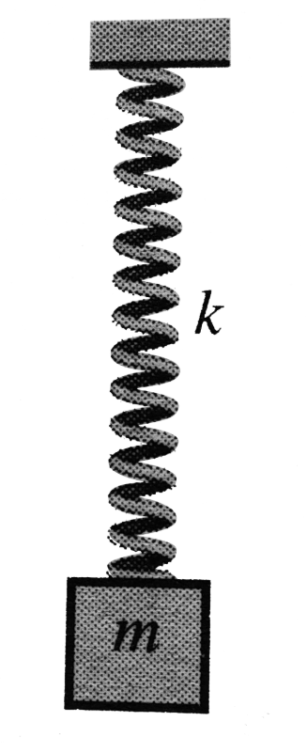
Figure 1: Simple Spring Pendulum

We use three different springs to observe the effects of spring constant(k) on peirod of simple pendulum. We know that increasing spring constant, increase the force per displacement. However, we must do the experiment to observe the effect in real life. Therefore, we use three different springs but two of them have same spring constant

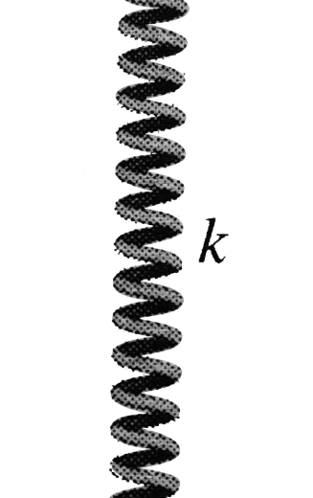
Figure 2: Different Springs but Same Constant

We must find the period of pendulum and result of we use LoggerlLite to find the period we select two peak points of force-time graph and we can reach the period.

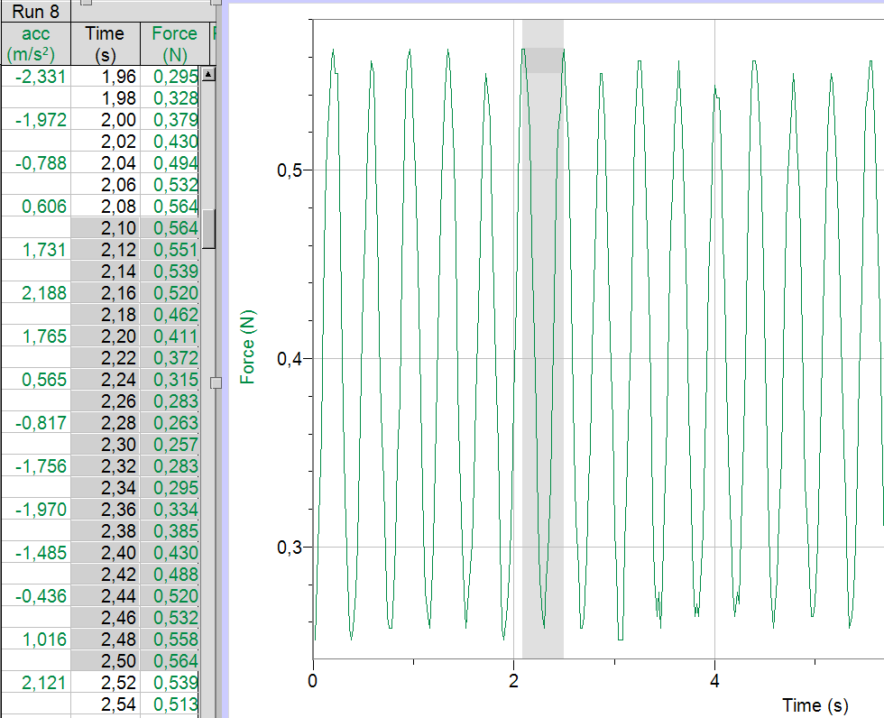

Moreover, We must find the spring constant. When we want to obtain spring constant we must use the following formula, F = Δx * k , as we can see on formula k depends on force (F) and displacement of spring (Δx). Again, we use LoggerLite graphs, int this case the graph we use is force-position graph because, the slope of this graph will give us the spring constant due to k = F / Δx.

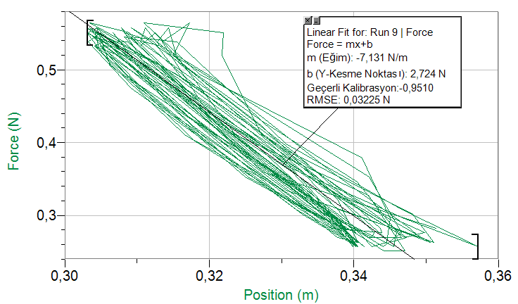

The period of the pendulum can be found in LoggerLite program, we can determine the peak points of force-position graph and substract the values to obtain period of pendulum. However if we calculate the period on this way we can not have the real value of period we will have an error margin. If we want to calculate the real value of period, we can use the formula below:
T = 2Π*√(m/k)

We can obtain the experimental force and displacement of spring form intital position using LoggerLite. Also, if we want to find real spring constant then, we use the formula below to find spring constant.
F = Δx * k
F / Δx = k

